**Open a restaurant in east Toronto**

In this Week im goint to check the diferences between the neighbourhoods of the East Toronto Borough, trying to understand what kind of business are well rated in each neighbourhoods and helping a business man that would like to know where to open a new restaurant and what kind of restaurant should it open in East Toronto Borough.

In order to do that, we are going to use the dataset from the previous week, filtering the final dataframe by East Toronto.

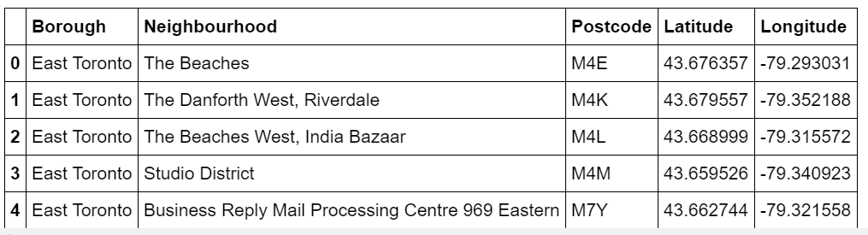

After that we are going to get some information about the shops in that area trying to find a market niche to deploy a new shop with more odds of success.

The data source is going to be FourSquare API, with that API we could have enough information to help the business man to deploy the best business according to the neighbourhood.

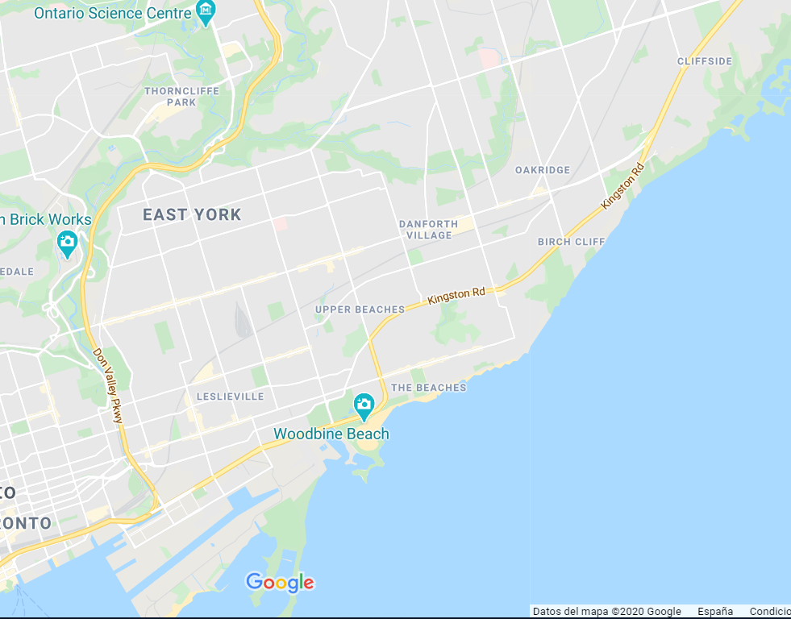

In the next picture we can see the shops opened in each of the neighbourhoods:

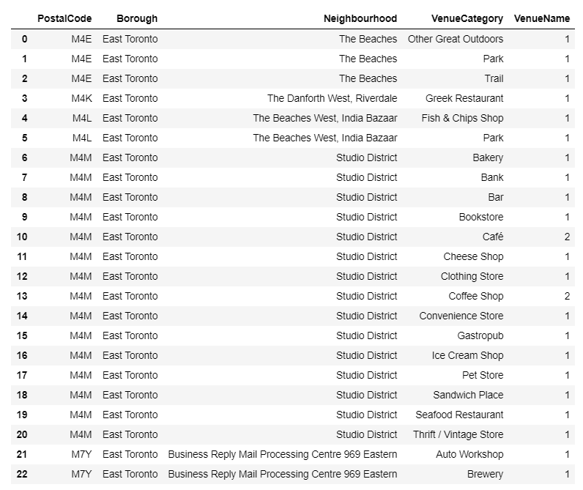

Analizing the Data we can see that there are two options to deploy a business:

- Option 1: the more risky way its try to open a shop/restaurant in the M7Y, M4E, M4K, M4L neighbourhoods. Why? it seems clear that in this neighbourhoods for some reason there are not restaurants or coffes, that could be because its not a residential area, furthermore, we can see that there isnt shops, so it isnt too a good commercial area (the people usually go to shopping to a area with more shops in order to find the best option.

- Option 2: the Sdudio District is the most popular neighbourhood in East Toronto, ther are shops, coffee shops, and much more business, so it seems to be the most crowded area in the borough.

After the analysis we decided to open a new chill out restaurant/pub in order to feed the people that came to spend the time in this area, and in the nights we are open in order to give cocktails to the clients.